Government & Politics - Find out more…

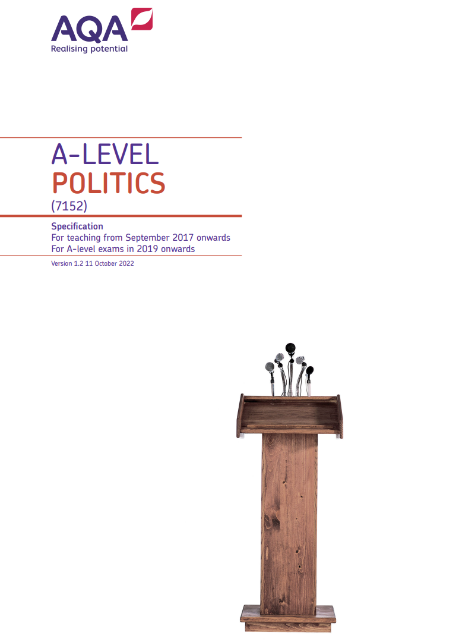
Dear Students,
Welcome to your ‘Find out more…’ page for Government and Politics. Lively, relevant, controversial… There are many ways to describe A-level Politics. It is one of the most interesting and engaging qualifications you can choose. Covering news and current affairs from the UK and US, it helps students understand how the United Kingdom is governed and aims to develop the research, written communication and debate skills of students who undertake the course. It is ideal if you’re considering studying politics, sociology, ethics, advertising or journalism at university and is highly regarded by employers in industries including politics, international organisations, the media, government and the civil service.
We are excited to be part of your decision making journey, and you are welcome to check in with us at any time to learn more about Government & Politics.
Mr N Mandalos, Mr S Newman, Mr D Hackett, Mr T Dale, Mr I Lukey
Subject specialists
Course details: A Level, Government & Politics
- Board: AQA
- Website
- NHSG Course information linked here
- Assessment style: Three examination papers - Paper 1 (UK Government and Politics), Paper 2 (US Government and Politics), Paper 3 (Political Ideas)
- Entry Requirements: Grade 4 in GCSE Maths and English or relevant Humanities/ Social Sc subject
- Destinations: Where can this subject take me, use the UCAS Browse Careers page to see more

