Economics - Find out more…

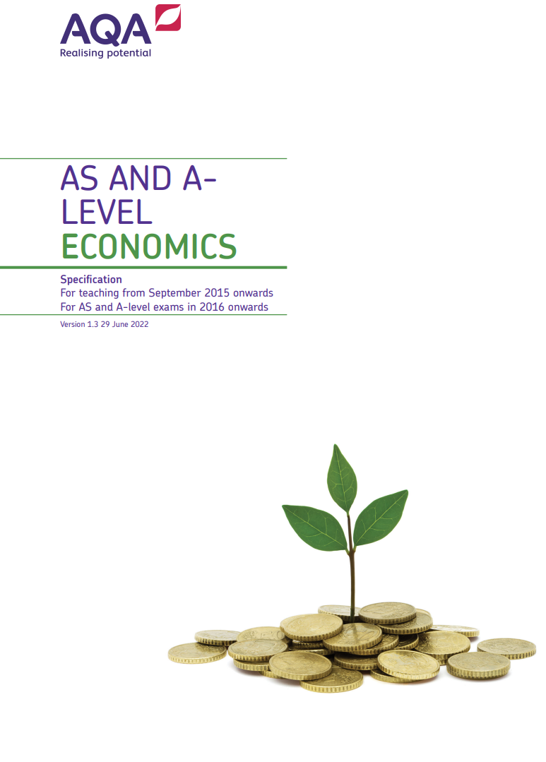
Dear Students,
Welcome to your ‘Find out more…’ page for Economics. Economics helps you understand the world around you – from the cost-of-living crisis to global trade. You’ll develop analytical and problem-solving skills by exploring how individuals, firms and governments make choices. The subject combines data, theory and current affairs, making lessons engaging and relevant. Economics is highly regarded by universities and employers, supporting careers in business, finance, politics and beyond.
We are excited to be part of your decision-making journey, and you’re welcome to check in with us anytime to learn more about Economics.
Ms Patel
Head of Economics
Course details: A Level, Economics
- Board: AQA
- Website
- NHSG Course information linked here
- Assessment style: 3 Papers, data response questions, multiple choice, essay questions
- Entry Requirements: Grade 5 in GCSE Economics or grade 5 in GCSE English and 6 in GCSE Maths
- Destinations: Where can this subject take me, use the UCAS Browse Careers page to see more

