Chemistry - Find out more…

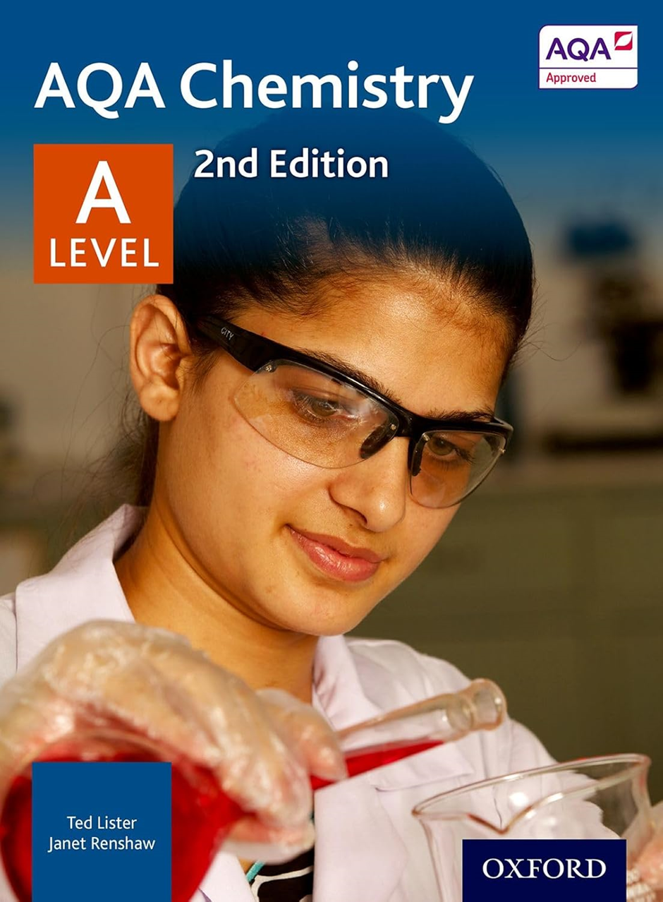
Dear Students,
Welcome to your ‘Find out more…’ page for Chemistry. Chemistry is a fantastic choice because it is everywhere — from tackling climate change and developing sustainable energy to creating new materials and advancing medical treatments. It helps you understand the world at a molecular level, explaining everything from how medicines work to why materials have particular properties. Combining theory with hands-on practical work, Chemistry allows you to apply your learning in the lab while developing logical, analytical, and quantitative thinking. It also teaches you to manage complex information, work systematically, and conduct precise experiments, all while enhancing teamwork and communication through collaborative lab work and reporting. A Level Chemistry is both challenging and rewarding, equipping you with critical skills, keeping your future options open, and giving you the tools to make a real impact in the modern world.
We are excited to be part of your decision making journey, and you are welcome to check in with us at any time to learn more about Chemistry.
Ms Shonubi
Head of Chemistry
Course details: A Level, Chemistry
- Board: AQA
- Website
- NHSG Course information linked here
- Assessment style: 3 exam papers and appropriate assessed practicals
- Entry Requirements: Grade 6 in GCSE Chemistry (triple) or grade 6:5 in combined GCSE Science Or ‘Alternative Academic Evidence Route’ also available
- Destinations: Where can this subject take me, use the UCAS Browse Careers page to see more

